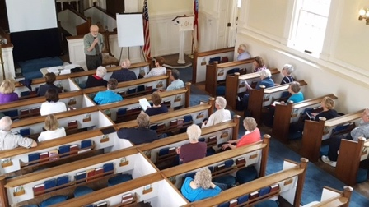

REGISTRATION FORM

FALL TERM OCTOBER 11 – DECEMBER 6, 2022
(No classes Thanksgiving Week)

NAME: | First Last | New Student?  YES NO
PHONE #: |  | New Phone#?  YES NO
EMAIL: |  | New Email?  YES NO
STREET 1: |  | New Address?  YES NO
STREET 2:
CITY:
STATE, ZIP CODE:

Indicate Class Choices:

Time | Course
9:00 - 10:00
10:10 - 11:10
11:20 - 12:00 | Q & A Informal “sit-down with Jerry”  (Class limit: 15) (See Description)
11:20 - 12:10 | 1st Lunch in Parish Hall
11:20 - 11:45 | 1st Yoga Break (25 minutes, limit 16)
12:20 - 1:10 | 2nd Lunch in Parish Hall
12:20 - 12:45 | 2nd Yoga Break (25 minutes, limit 16)
1:20 - 2:20
2:30 - 3:30

Please complete form and mail with $125 payment (check or money order) made payable to “SAGE Community” to: SAGE c/o Christ Church Episcopal, 21 E. Aurora St., Hudson, OH 44236

